Game Development

Homework 2

Introduction

This is part of the Game Design Document for a hypothetical project “Qiz Qalasi Defense” submitted for partial fulfillment of the requirements of the Game Development Fundamentals course in the School of Information Technologies and Engineering at ADA University, Baku, Azerbaijan.

The name of the game which is designed by “Bakililar” team is called “Qiz Qalasi Defense”. This game is non-violent, single player, which take place in Baku, Azerbaijan.

First of all tower defense game is the most popular game according to its game types of the history and therefore we are planning to create this type of game with the same genre. We will try to make offline single player game that every user will play with great pleasure. Player knows that the game is offline single player game with no internet connection. Before game screen is opened there will be START, EXIT and ABOUT writings. With entering START the game will be opened with basic abilities given to player in the beginning. Our game is based on 3D PC game and no need for any static background. We will try to make our environment more realistic as possible as and will put some realistic object to our game. Our team also make the 3D design of Flame Towers drawn by Blender that will be used in our game. Enemy objects has been developed from scratch in Blender (3d Graphics Software) by our teammate Arsalan Iravani. In the game, cars will have different colors. Maiden Tower, crucial object which is supposed to be defended from the enemies. In addition, level by level the viability and speed will increase. We try to develop and improve the process of objects in better way. According to the architectural complexity of our objects such as Maiden tower, Flame Tower and etc, our team gives efforts both to make it on time and design photorealistic architectural model of the architectures which can be implemented in real time. Our game is offline single player game and will not be any level difficulty. In the first level, Qiz Qalasi will be placed in the center of screen. To the right end of the screen sea will be demonstrated. This will be same for all levels however view of buildings will change substantially from level to level. In the first level, basic city road will be demonstrated. After player succeeds with opening higher levels the city will be as Baku city. It will be more like Baku city in higher levels as new buildings will be added. In 3D games map plays special role for the users that can easily navigate on the territory and do not get lost. Here the map of the “Qiz Qalasi” was designed by our “Bakililar” team:

GAME MATRIX

|  |  |
| --- | --- |
| NAME | DESCRIBTION |
| Map | The territory map which includes birds eye view in which architectures and other objects of close terrain of player will be seen. |
| Player | The important character in game which user will control each of their customized players |
| Rocket | Is used to make the enemies down |
| Qiz Qalasi | The Place where we should protect |
| Tree | An element which is not related with users but will be added to make more realistic look |

**Game Flowchart**

The below is general game flowchart:

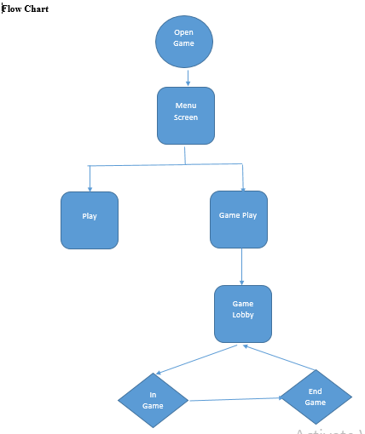

**System Requirements**

Minimum Hardware Requirements:

800 Mhz Intel Pentium III or 800 Mhz AMD Athlon or 1,2 Ghz Intel Celeron or 1,2 Ghz AMD Duron processor

128 MB of RAM

32 MB video card with DirectX 9.0 compatible drivers ("GeForce" or better)

8X speed CD/DVD drive

Sound Card with DirectX 9.0 compatible drivers

915 MB of free hard disk space (+ 635 MB if video card does NOT support DirectX Texture Compression)

Windows 98, 98 SE, ME, 2000, XP or Vista

DirectX 9.0 or higher

Keyboard and Mouse

Recommended Hardware Requirements:

Intel Pentium IV or AMD Athlon XP processor or higher

256(+) MB of RAM

64(+) MB video kcard with DirectX 9.0 compatible drivers ("GeForce 3"/"Radeon 8500" or better with DirectX Texture Compression support)

16 speed CD/DVD drive

DirectX 9.0 compatible sound card with surround sound

1.55 GB of free hard disk space (+635 MB if video card does NOT support DirectX Texture Compression)

Windows 98, 98 SE, ME, 2000, XP or Vista

DirectX 9.0 or higher

Gamepad (USB or Joystick Port)

Keyboard and Mouse